MCQ—

1. 4

2. 1,3,4,5

3. 2

4. 3

5. 1

6. 2

7. 3,4,5

8. 2

9. 3

10. 4

11. 4

12. 1,2,3

13. 4

14. 2

15. 2

16. 3

17. 1

18. 2

19. 4

20. 2

>>Validation Rule 1

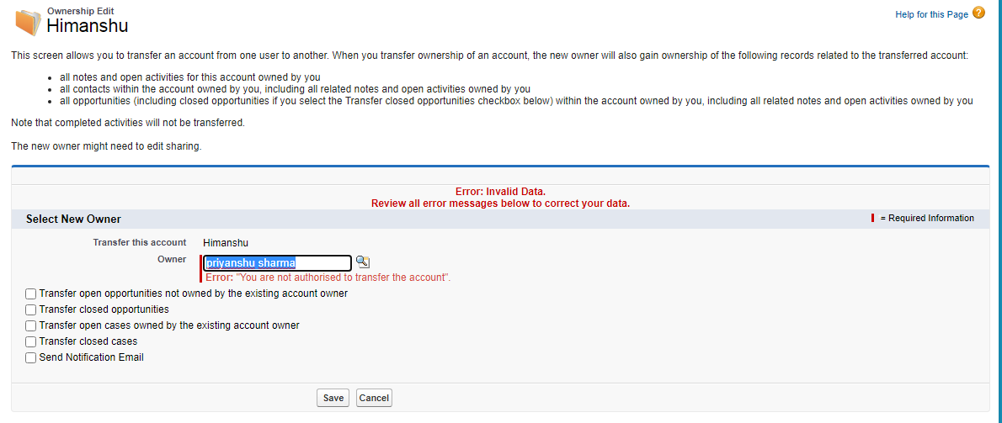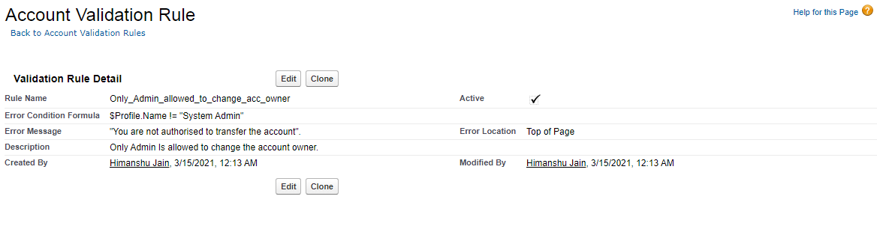

Validation Rule 2

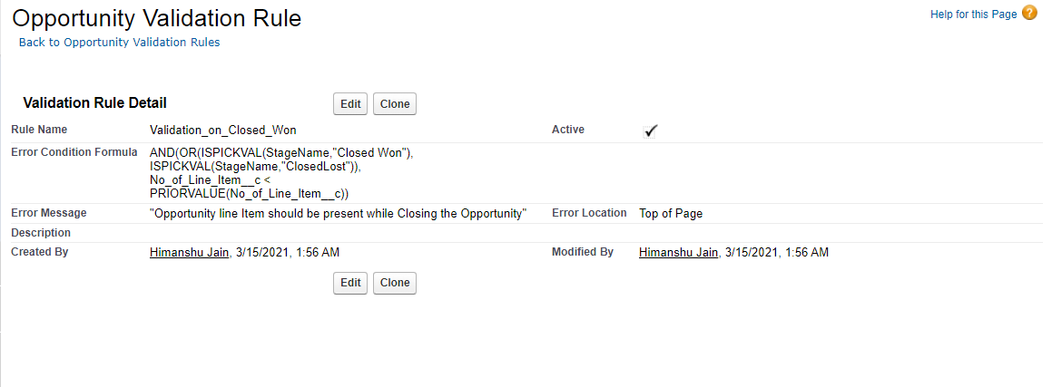

>>Work Flow Rule

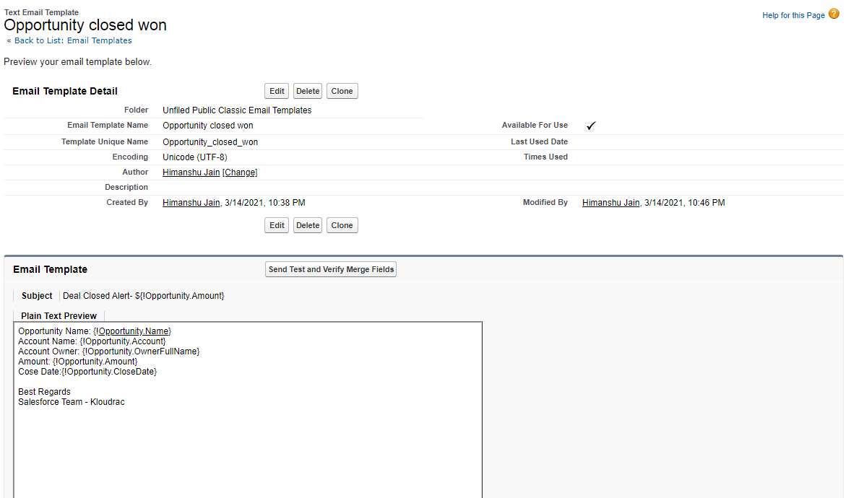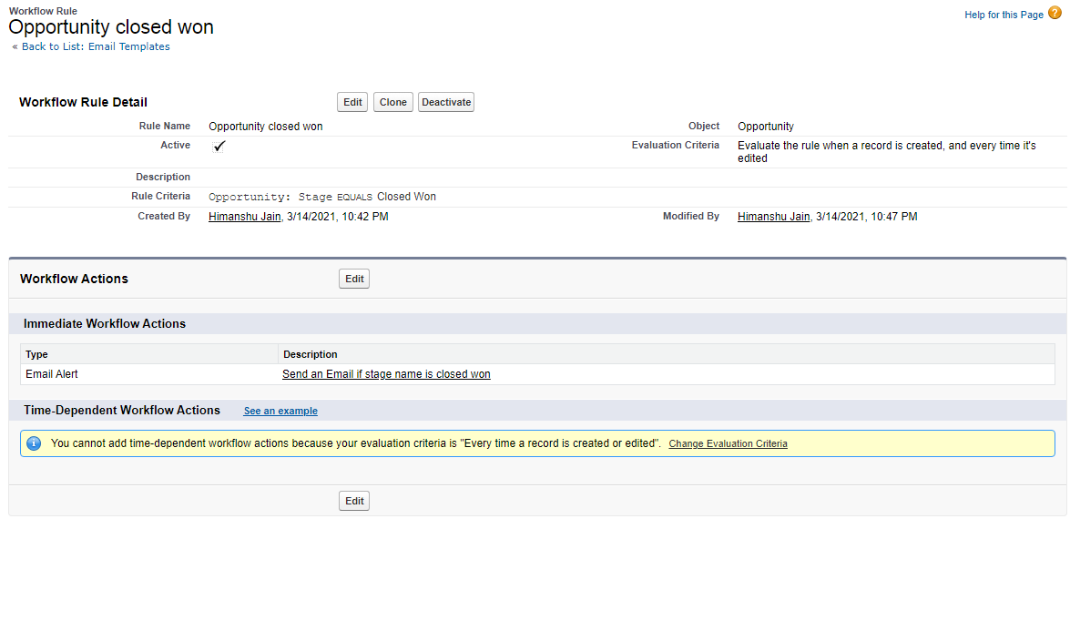

>>Process Builder

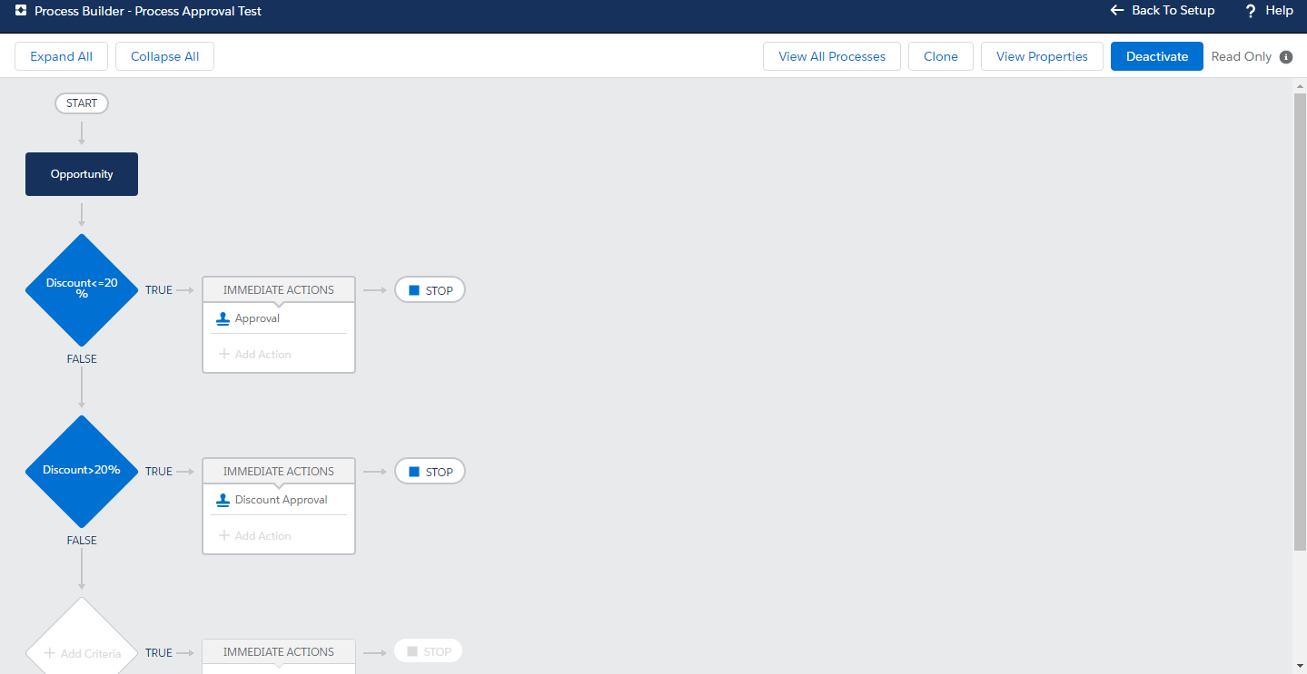

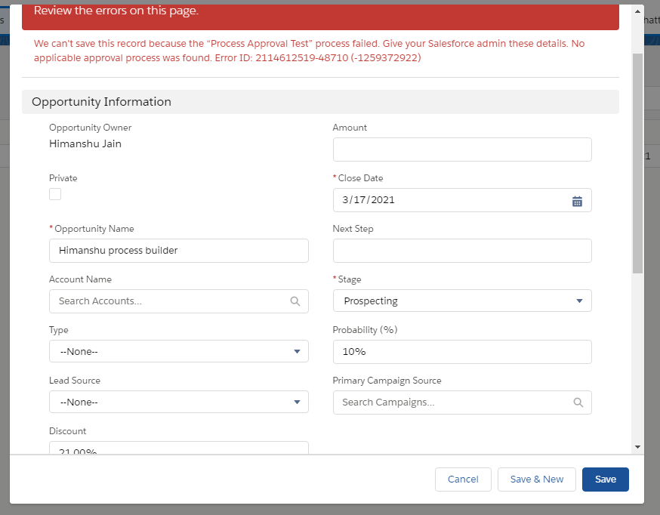

Trigger 2

trigger newopportunity on Opportunity (after insert)

{

list<Opportunity> opplist: trigger.new;

if(opplist.size()> 0)

{

opplist.Product__c= [ Select Product__c from opportunity where limit 5];

}

}